**Enable Shukran Parameter**

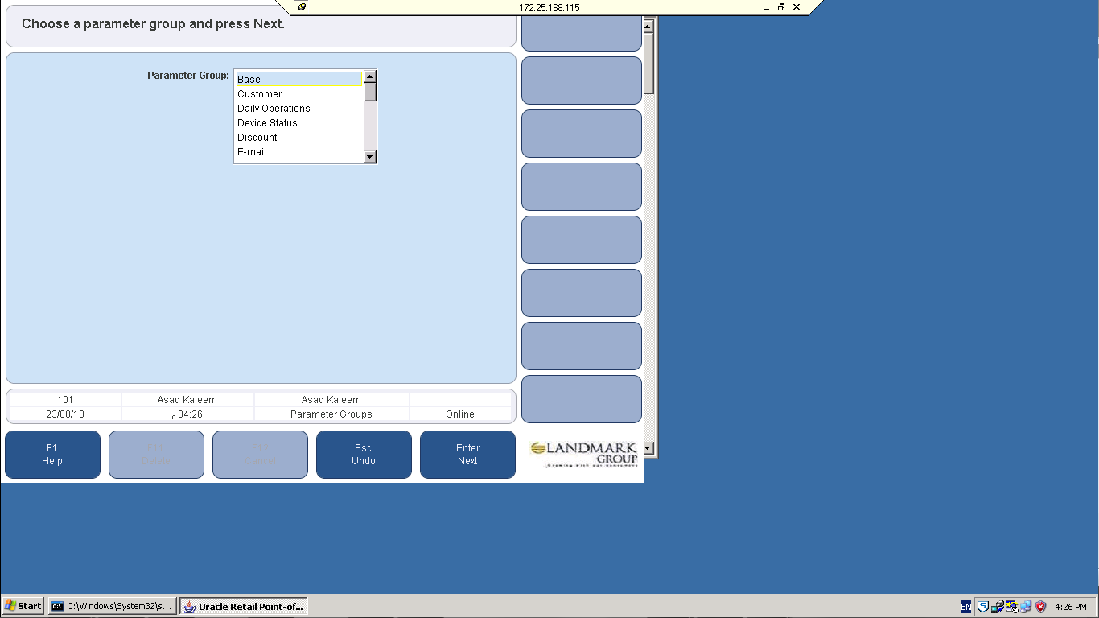

**Parameter 🡪 Shukran Earn and Burn = YES**

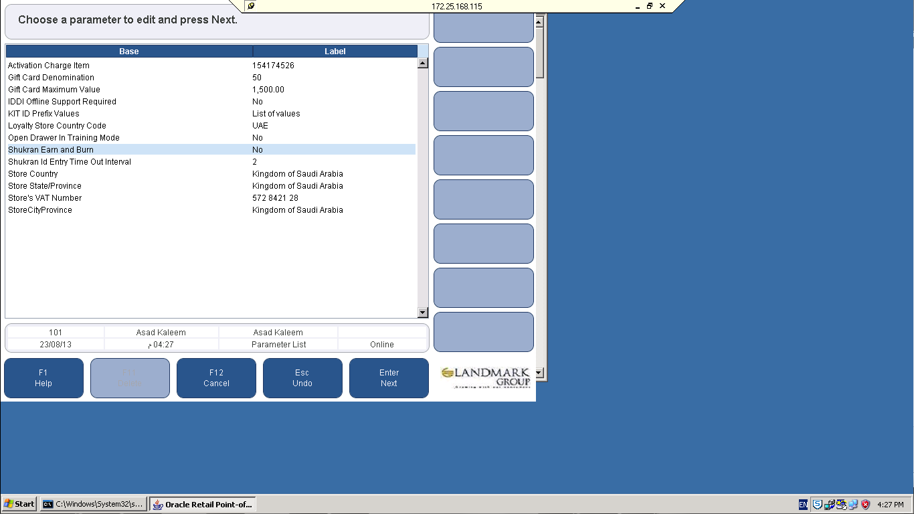

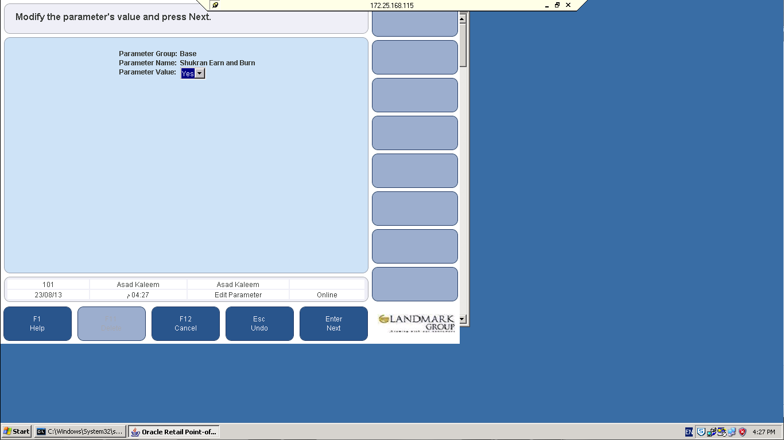

**Parameter 🡪 Loyalty Store Country Code.**

**Note :** This parameter is territory specific so choose as per you terriotery (For Ex: Egypt).

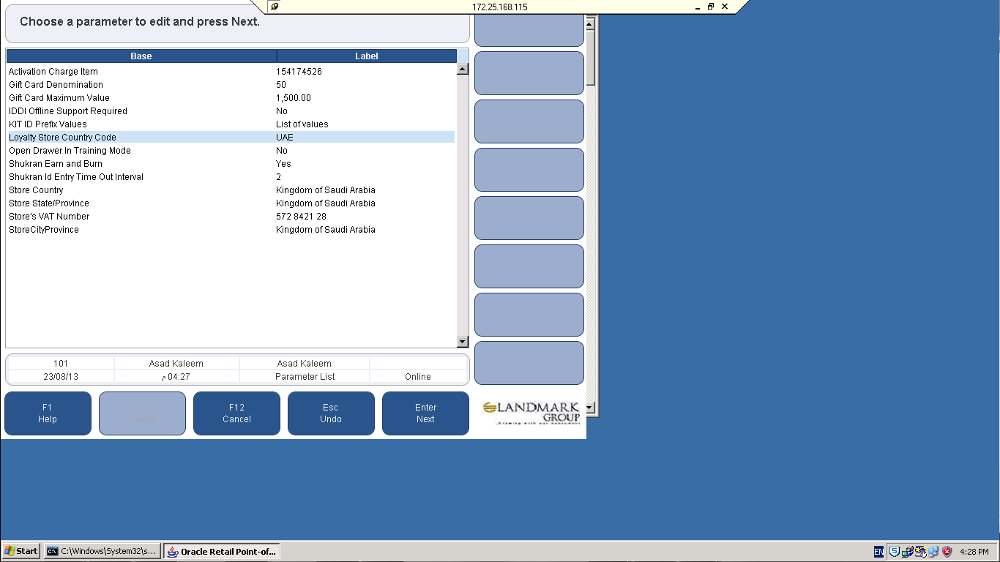

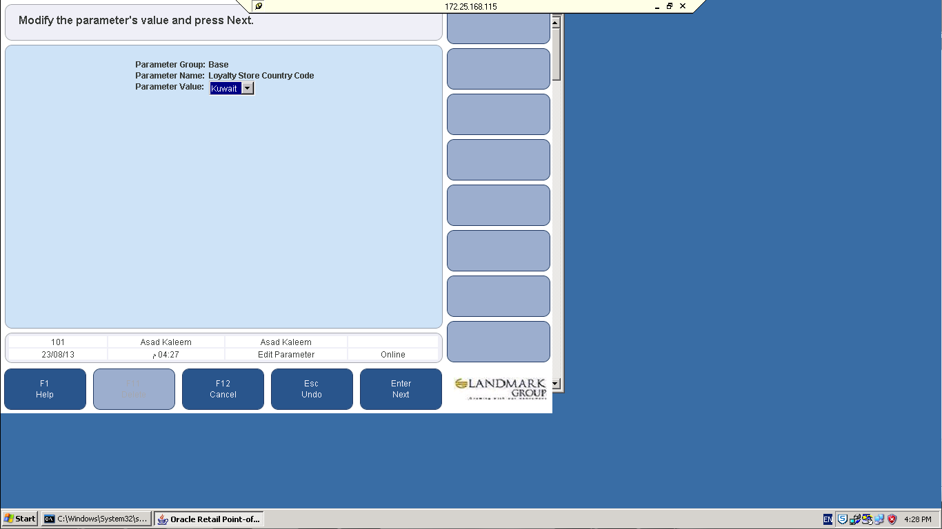

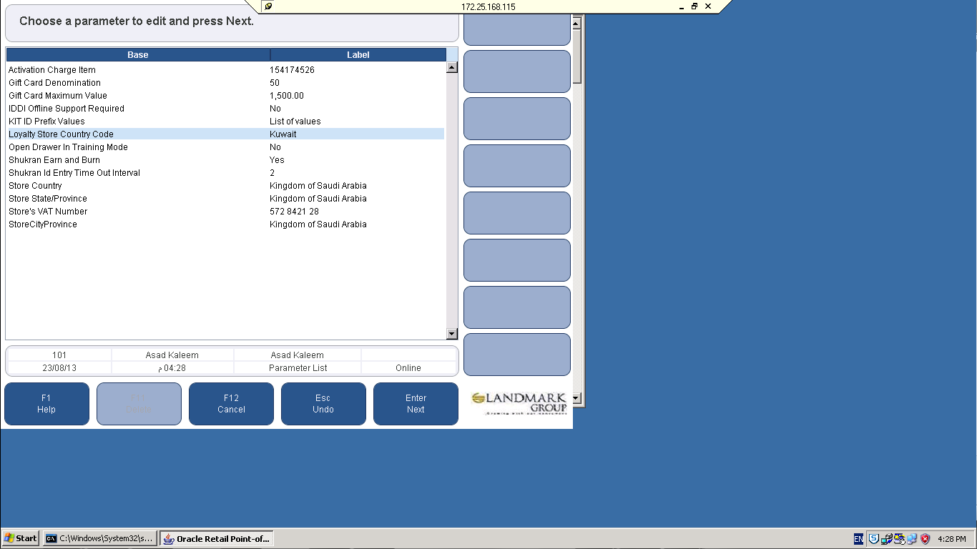

**Parameter 🡪 Store Country.**

**Note :** This parameter is territory specific so choose as per you terriotery (For Ex: Egypt).

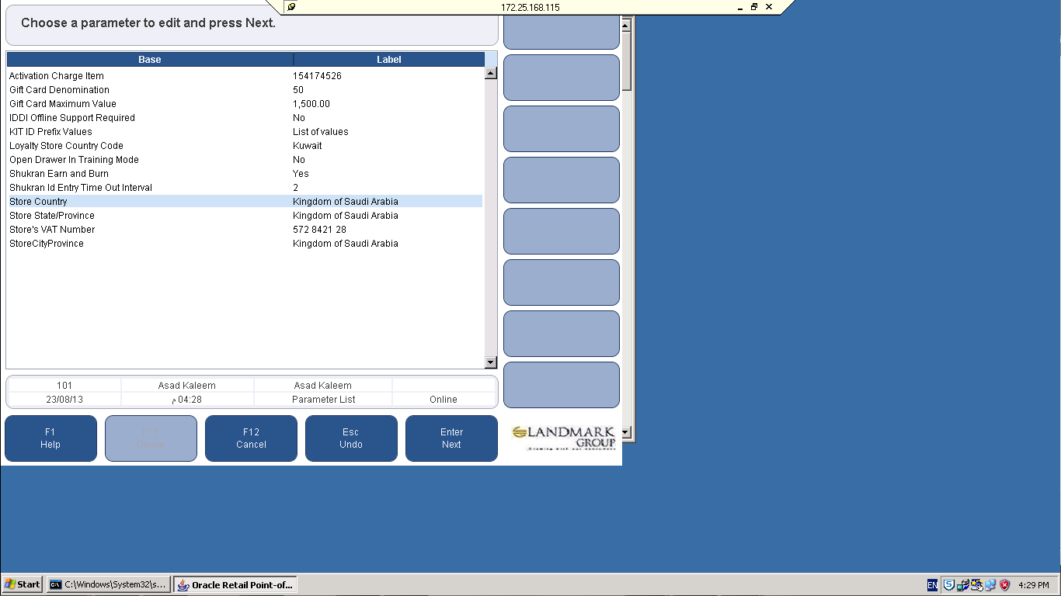

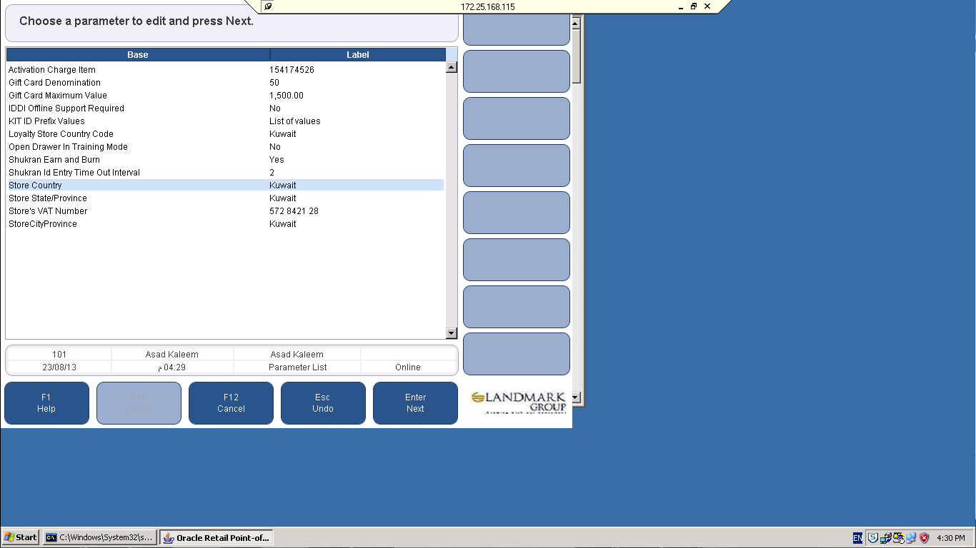

**Parameter 🡪 Store State/Province**

**Note :** This parameter is territory specific so choose as per you terriotery.

